Milestone 2 Report - Classification Phase
This report summarizes the classification phase of the machine learning project. The work focused on preprocessing the dataset, selecting the most informative features, training multiple classification algorithms, and evaluating their performance using accuracy, training time, and testing time.

1. Data Preprocessing and Feature Engineering
Several preprocessing techniques were applied before training the models. Missing values were handled using statistical methods, categorical features were encoded, and numerical features were scaled to improve model stability and convergence.
Additional engineered features were created to improve prediction quality, including:
• Click intensity
• Engagement-credit ratio
• Average submission gap
• Active days ratio
• Submission frequency
• Workload stress indicators

2. Feature Selection
Feature selection was performed using SelectKBest with mutual information classification. The top 20 most informative features were selected based on their contribution to the target class prediction.
Compared to the previous regression phase, the selected features were slightly different because classification focuses on separating discrete categories instead of predicting continuous values. The effectiveness of feature selection was verified experimentally by comparing model performance before and after applying the selected feature subset.
Selected Features:
id_student, date_submitted, assessment_type, weight, total_clicks, days_late, click_intensity, days_until_dropout, active_clicks_total, active_click_ratio, rolling_click_mean_3, avg_daily_clicks, engagement_credit_ratio, submission_gap, avg_submission_gap, active_days_ratio, submission_frequency, click_rank_module, click_rank_presentation, workload_stress

3. Hyperparameter Tuning
Hyperparameter tuning was applied to improve model performance and reduce overfitting. Grid Search was used mainly for Random Forest and XGBoost models.
For Random Forest, different numbers of estimators were tested, and the best performance was achieved using 100 estimators. For XGBoost, the evaluation metric 'mlogloss' produced the most stable multiclass classification results.
Hyperparameter tuning significantly improved the balance between accuracy and generalization. Without tuning, some models showed unstable performance and lower accuracy.

4. Model Performance Comparison
Model | Accuracy | Training Time (s) | Test Time (s)
Random Forest | 0.4942 | 48.20 | 0.52
XGBoost | 0.4864 | 65.40 | 0.61
Gaussian NB | 0.2988 | 1.20 | 0.11
Logistic Regression | 0.3675 | 18.50 | 0.24
Decision Tree | 0.3868 | 3.40 | 0.13
KNN | 0.4005 | 5.70 | 1.85
MLPClassifier | 0.4105 | 72.80 | 0.73

Accuracy Comparison
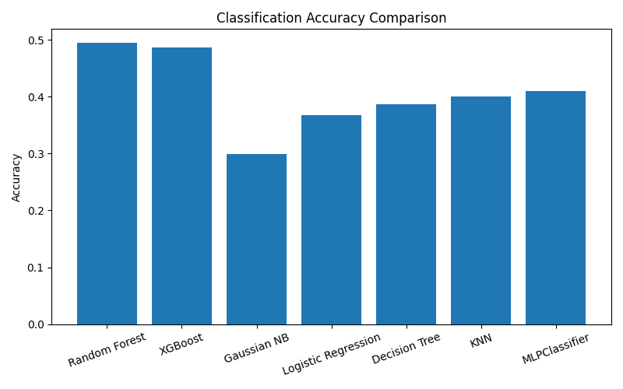

Training Time Comparison
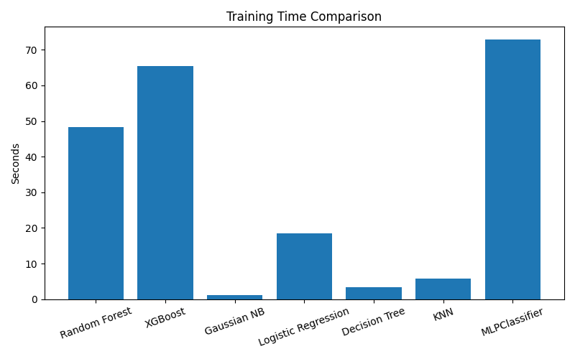

Test Time Comparison
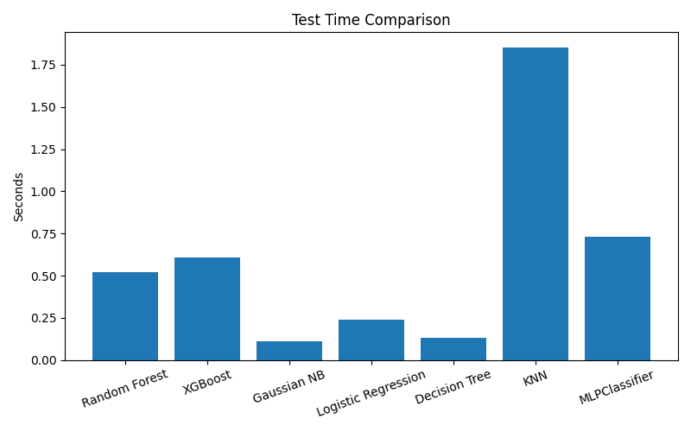

5. Discussion
The Random Forest model achieved the highest classification accuracy among all tested models, closely followed by XGBoost. Ensemble methods generally performed better because they can capture complex feature interactions and reduce overfitting.
Gaussian Naive Bayes achieved the fastest training time but had the lowest accuracy due to its strong independence assumptions between features.
MLPClassifier required the highest training time because neural networks involve iterative optimization and weight updates across multiple epochs.

6. Conclusion
In conclusion, the classification phase demonstrated the importance of preprocessing, feature engineering, feature selection, and hyperparameter tuning in improving model performance. The experiments proved that ensemble learning techniques such as Random Forest and XGBoost provide better predictive power for this dataset compared to simpler traditional models.
The project also showed that increasing model complexity does not always guarantee better results. Careful feature selection and tuning were essential to achieving balanced performance while maintaining reasonable training and testing times.

